Jared Morell

ECE 570.S – Software GPS Receiver

Homework 10

In order for the performance of an analog-to-digital converter (ADC) to be analyzed, a signal first needed to be constructed. Using the input amplitude, signal frequency, and sampling frequency, a discrete time sinusoid was formed. Gaussian noise was then added to the signal, using normally distributed random numbers.

To digitize the signal, a step size between quantization levels first needed to be established, as follows:

Delta = vpp/(2^n-1)

where delta is the step size, vpp is the peak-to-peak voltage of the sinusoid, and n is the number of bits to be used for quantization. Using this step size, the analog signal could be assigned to the closest quantization level. Plots of the discrete original signal, signal with noise, and the digitized signal can be seen below:

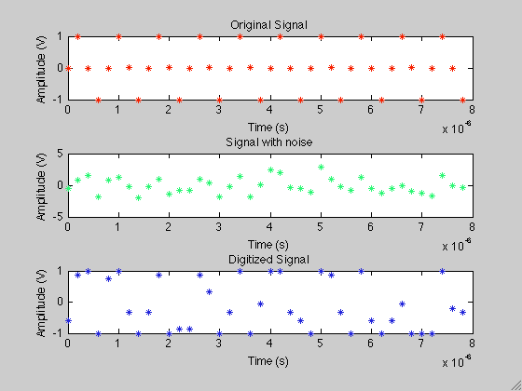

To determine the signal-to-noise ratio (SNR) of both the original and digitized signals, the Fourier transform was applied to each signal to obtain their spectrums. These can be seen below:

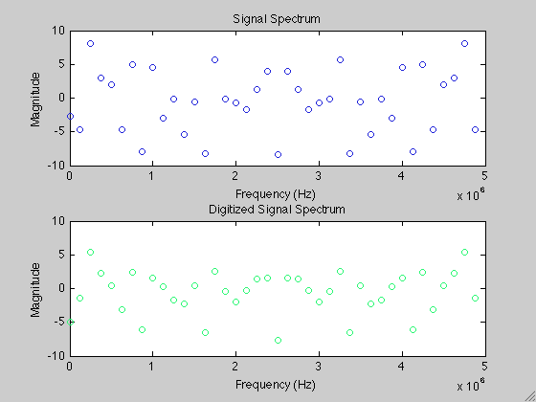

In calculating SNR, both signal and noise power are used. A sinusoidal signal’s power, PS, is found simply by squaring the amplitude of the signal. To find the random noise power however, the following formula is used,

PN = (sum(abs(xf).^2)-2*abs(amp)^2)/(n-2)

Finding the SNR, in dB’s, is then done as follows,

SNR = 10*log(PS/PN)

Five runs of the program were then conducted and SNR was calculated for both the original and digitized signals. The results are shown in the table below.

|  |  |  |
| --- | --- | --- |
| **Run #** | **x (original signal with noise)** | **xd (x, quantized with 4 bits)** |
| 1 | 10.0178 | 10.1889 |
| 2 | 7.6244 | 6.5364 |
| 3 | 10.7932 | 10.7254 |
| 4 | 10.9141 | 11.1262 |
| 5 | 11.8684 | 12.3723 |